Experiment No.: 4
Title: Palindrome Checker using Function Types, Scope, Closure, and Try-Catch
- Software/Tools Required:VS Code,Web Browser,HTML, CSS, and JavaScript
- Theory: A palindrome is a word, phrase, or sentence that reads the same forward and backward. For example, madam, racecar, and A man a plan a canal Panama are palindromes.

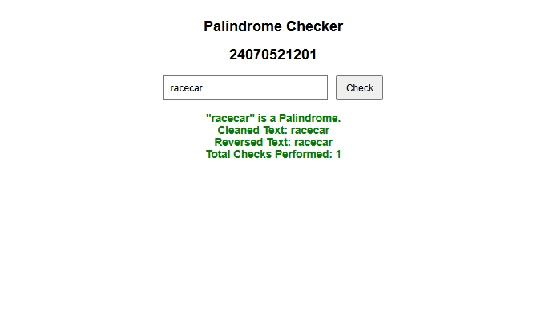
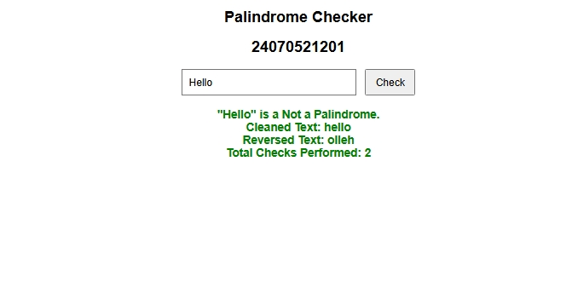

Result: The palindrome checker program was successfully implemented using HTML, CSS, and JavaScript. The program accepts user input, removes spaces and special characters, converts the input to lowercase, reverses it, and compares it with the cleaned input.The program correctly identifies whether the given input is a palindrome or not. It also handles empty input and invalid input using try...catch.

Conclusion: This experiment demonstrates the practical use of JavaScript functions, scope, closures, and error handling. By building the palindrome checker, different function types such as function declarations, function expressions, and arrow functions were understood clearly.The concept of scope helped in managing variable accessibility, while closures were used to maintain a private count of the number of checks performed. The try...catch block helped in handling invalid or empty input safely.Overall, the experiment provided hands-on experience in applying important JavaScript programming concepts in a real web-based application.

